**OLOFU GABRIEL**

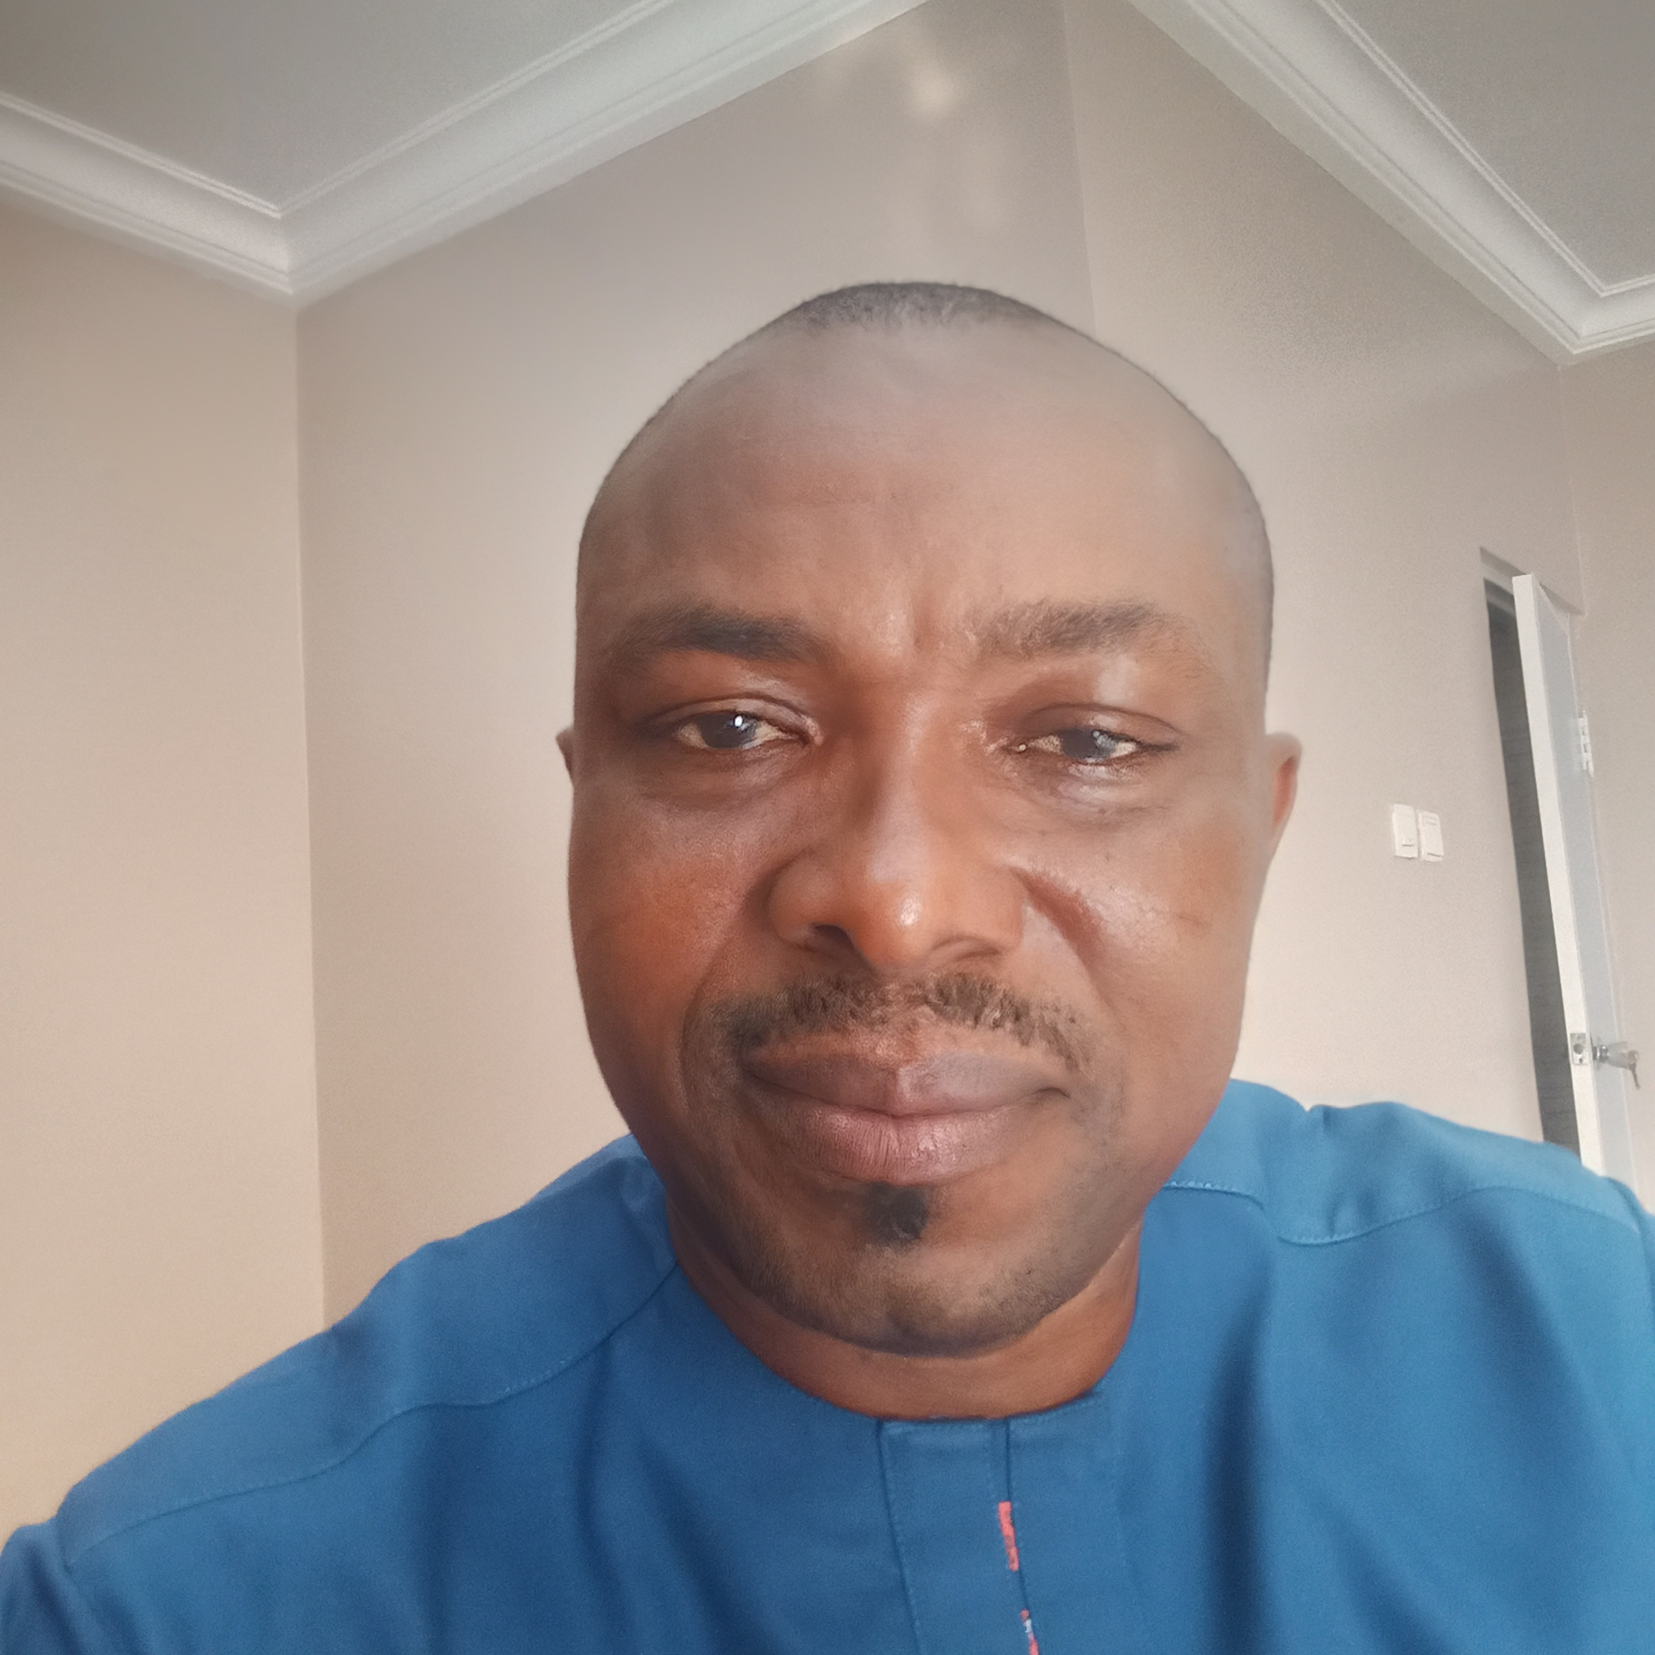

**Email:** [gavlon111@gmail.com](mailto:gavlon111@gmail.com)

**Tel:** 08064632670

**PERSONAL DATA:**

Surname: Olofu

Other names: Gabriel

Date of Birth: 10th March, 1970

Place of Birth: Adoka

Local Govt. Of Origin Otukpo

State of Origin: Benue

Nationality: Nigerian

Sex: Male

Marital Status: Married

**OBJECTIVES:**

Committed to hard work, dedication diligence, teamwork, excellence and merits are my core values and where opportunities exist for development and career advancement.

**INSTITUTIONS ATTTENDED WITH DATES**

* Benue State Polytechnic Ugbokolo Feb 2014
* Benue State Polytechnic Ugbokolo August 2012
* Benue State Polytechnic Ugbokolo April, 2011
* Institute of Education (ABU) Zaria 1993
* Ajegbe Secondary School Awume 1986
* LGEA Primary school Okpaflo-Adoka 1981

**QUALIFICATIONS OBTAINED WITH DATES**

* Higher National Diploma(Business Administration/Management) Feb 2014
* National Diploma (Business Studies) Aug. 2012
* Advanced National Diploma(Public Administration) April 2011
* National Certificate in Education (NCE) 1993
* West African Examination Council (WAEC ) 1986
* First School Leaving Certificate (FSLC) 1981

**WORK EXPERIENCE**

* Secretary Otukpo Local Government Council 2007
* Vice Chairman Otukpo Local Government Council 2009
* General Manager, Leach Investment Nig. Ltd Otukpo 2009-2011
* Chairman Otukpo Local Government Council 2012
* Senior Special Assistant Governor of Benue State 2015-2019
* Senior Special Assistant Governor of Benue State 2019-2023

**REFEREES**

**Prof. Godwin Anjenu Abu**

University of Agriculture

*Tel: 08036074434*

**Prof. Innocent Ujah**

Vice chancellor. University of Health Sciences Otukpo

*Tel: 08086575544*